## PRESS RELEASE:

## SmartCHANGE.eu to deliver AI-based long-term health risk evaluation for driving behaviour change strategies in children and youth

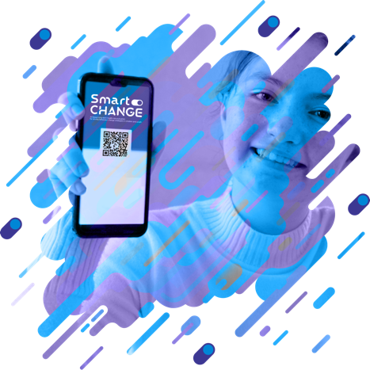

*[Ljubljana- Slovenia - June 2023] Introducing SmartCHANGE: A breakthrough EU funded project to predict and address Long-Term Risks of Non-Communicable Diseases in Youth.  
Non-communicable diseases, such as heart disease and cancer, have silently incurred greater healthcare resources worldwide than the attention-grabbing COVID-19 pandemic. Alarming statistics reveal that these diseases often stem from unhealthy habits formed during youth, emphasizing the urgent need to address this issue proactively.*SmartCHANGE is taking a bold step in the fight against non-communicable diseases, by aiming to develop advanced AI-powered models capable of predicting long-term risks of cardiovascular and metabolic diseases in individuals aged 5 to 19.   
 *The project’s first physical plenary meeting took place on 23-24 May 2023 in Ljubljana, Slovenia.*

___________________________________________________________________________

For all the publicity received by the COVID-19 pandemic, you may be surprised to hear that non-communicable diseases (such as heart disease and cancer) easily surpass it worldwide as the primary cause of death and healthcare expenses. These diseases often trace back to unhealthy habits formed during youth, highlighting the significance of addressing this issue early on.

Enter SmartCHANGE, an ambitious research and innovation project **launched in May 2023** under Horizon-Europe. Its main objective is to develop advanced AI-powered models that can predict long-term risks of cardiovascular and metabolic diseases in individuals aged 5 to 19. This age group is particularly susceptible to unhealthy lifestyle choices, making it crucial to intervene and promote healthier habits. By accomplishing this goal, SmartCHANGE actively contributes to the United Nations Sustainable Development Goal of ensuring lifelong good health and well-being for all citizens.

The four-year project has an exciting work plan to achieve its goals:

* **Personalised Risk Predication**. SmartCHANGE will pursue new advances in health-focused machine learning to provide analyses of health data that are tailored to diverse age groups, explainable, transparent, and fair – all with firm guarantees of privacy and confidentiality;
* **Web App for Professionals**. Health professionals will have a user-friendly web application allowing them to evaluate and manage health risks related to unhealthy lifestyles, while utilizing AI to tailor the analyses to individuals to permit optimal recommendations;
* **mHealth App for Citizens**. At the same time, citizens will be empowered by our mobile app to take their health-related lifestyle choices into their own hands, receiving expert, AI-powered recommendations to create enduring, healthy habits for life;
* **Promoting Wellness and Prevention Best Practices**. The multi-pronged research, innovation, and exploitation activities of SmartCHANGE will help to further the state of practice in both institutions and in the lives of private citizens, in areas ranging from legal and public policy to technical and social.

**The SmartCHANGE Partners**

The project is coordinated by the Jožef Stefan Institute, Slovenia's leading scientific research centre, leading a consortium of thirteen international, multidisciplinary partners, with expertise in AI, legal and public policy issues, healthcare, software engineering, social science, and communication. The consortium includes both small and large commercial enterprises and prestigious academic research institutions with strong connections to health-related policymaking and disseminating entities.

**Join the SmartCHANGE Community!**

Further details and updates about the development of SmartCHANGE.eu will be disseminated through the official website, via our social media channels Twitter and LinkedIn and YouTube channels as well as via a regular SmartCHANGE.eu newsletter.

Sign up for our newsletter at [SmartCHANGE Newsletter](https://www.smart-change.eu/#newsletter)

**Follow us on Social Media:**

Twitter Logo Vector Art, Icons, and Graphics for Free Download @SmartCHANGE_eu

/company/smartchange-eu



 @SmartChange-eu